Use case

In this app, you can store data of money spending.

For the top half part,

There are five blanks you can type in stuff. They are about the day, month, year, amount, and category.

There is also a plus sign and minus sign which represent positive amount and negative amount. A positive amount is for adding money, a negative amount is for spending money.

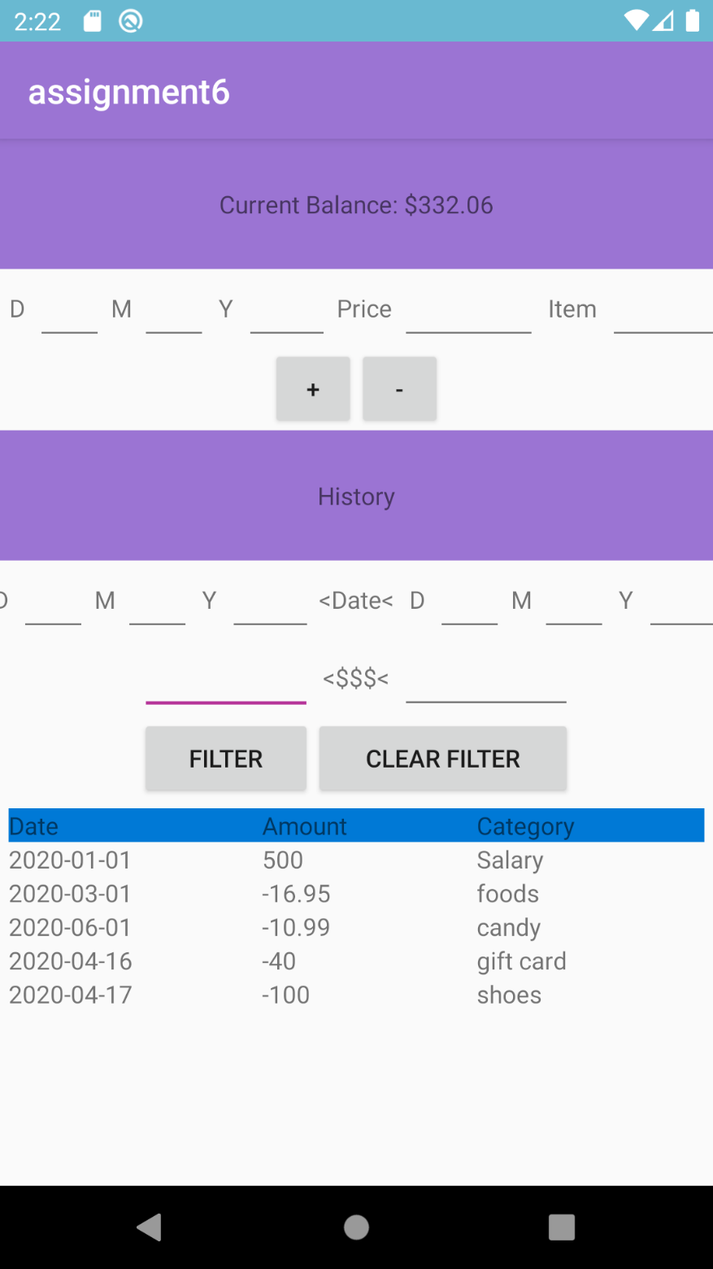

For the bottom half part,

To click filter button so You can check the transaction between some dates, and/or having amount between some values.

History will declare that part of transcarion you chose.

